## **Project 1 Report: Pythonic IRC**

**Introduction**

The project requirements were to implement an Internet Relay Chat (IRC) in python using web sockets. Though this may sound simple, I stumbled upon obstacles. For starters, I have never used Python before. I typically prefer compiled languages as opposed to interpreted languages. I made a game plan to make an efficient attack strategy and referenced sites like IRC commands from Internet Engineering Task Force (IETF) for an understanding of each command and Stackoverflow when I was stumped for implementation in python.

I found myself running into Python’s implementation of Object Oriented Programming (OOP) more than anything else. After this project, I can say I have a deeper understanding of web sockets and I am more comfortable in using Python as one of my preferred languages.

**Problem Statement**

The overall problem at hand was to implement an IRC; I ran into several other problems along the way. One major obstacle I encountered was understanding how Python works. As previously stated, I have never used Python before and this project expected me to have at least an average understanding of how websockets works. One of the more minor obstacles was how I was going to structure everything and learning some of Python’s built-in functionality and behavior.

**Methodology**

My methodology was well planned out; I started with the back end structure. I went over some design patterns that I know of and decided no to go that approach considering it would have further delayed me. Some questions that led me to my current implementation were: How can I efficiently encapsulate relevant data?; How can I access class functions without instantiating an object?; How can I ensure there’s no fall-through in some command implementations?   
I tackled encapsulation by creating classes I deemed relevant for this assignment, ie. user, channel, and commands. In the user class, I took care of relevant user information such as name, nickname, password, etc. In the channel class I took care of things such as Channel operators, channel password, and if the channel was private or public. I implemented the commands class as the controller of of my project; it handled the flow of the program, where information should be passed to, and it implemented all the irc commands as well.  
The second plan to my attack strategy was to access class functions without instantiating their object twice. I encountered a problem where I needed the Server’s self inside of my command class in order to call the Server class’ function as opposed to the objects function. I also ran into another problem where there could be duplicates of the same channel; to solve this, I made the channel dictionary belong to the commands class instead of the object, thus I made the dictionary static. During this project, I found that static context was very useful because of possible concurrency issues.  
Third, I ensured that there was no fall-throughs by constantly debugging and using boundary test cases and test cases that would normally through an exception. I do so by adding consistent checkpoints at every point I found a fall-through. In fact, where I work has made me a stronger tester, so I preemptively caught possible exceptions and errors.

**Results**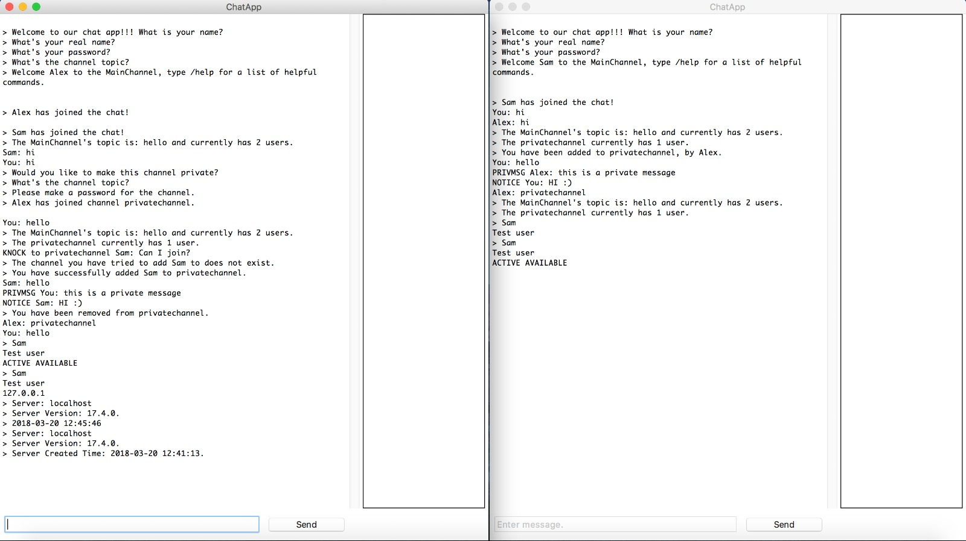

In the screenshot I have provided on the left, I show the interaction between two users on the server utilizing commands.

The commands displayed are:

• Join, Knock, Notice, Part, Invite, Version, Time, Info

All the commands implemented work, even when purposely meant to fail. Some intangible outcomes were my knowledge in Python grew significantly, my knowledge in websockets grew significantly, and I learned about concurrency in the form of multi-threading.

**Analysis**

I am overall pleased with the project we received. It strengthened some of my programming fundamentals as well as taught me a language along the way. I used methods that I learned previously to help me ensure proper functionality of my project. What I found most useful in this project were some concepts learned in programming 2 as well as others learned in data structures. I also found it was better to use an IDE such as Pycharms, because it allowed for debugging properly as opposed to debugging like most interpreted languages do.

**References**

Kolek. Nov. 2011. How do I check the operating system in Python?.

https://stackoverflow.com/questions/8220108/how-do-i-check-the-operating-system-in-python

lal rishav. Apr 2017. How to know that clients disconnects server in socket.

https://stackoverflow.com/questions/43178999/how-to-know-that-clients-disconnects-server-in-socket

Oikarinen, J. May 1993. Internet Relay Protocol. https://tools.ietf.org/html/rfc1459

Nn2. Jan 2011. Editing specific line in text file in python.

https://stackoverflow.com/questions/4719438/editing-specific-line-in-text-file-in-python

Vishal Yarabandi. Mar 2016. How to know the if the socket connection is closed in python?.

https://stackoverflow.com/questions/35861484/how-to-know-the-if-the-socket-connection-is-closed-in-python

Zjm1126. May 2010. Is there a simple way to delete a list element by value.

https://stackoverflow.com/questions/2793324/is-there-a-simple-way-to-delete-a-list-element-by-value